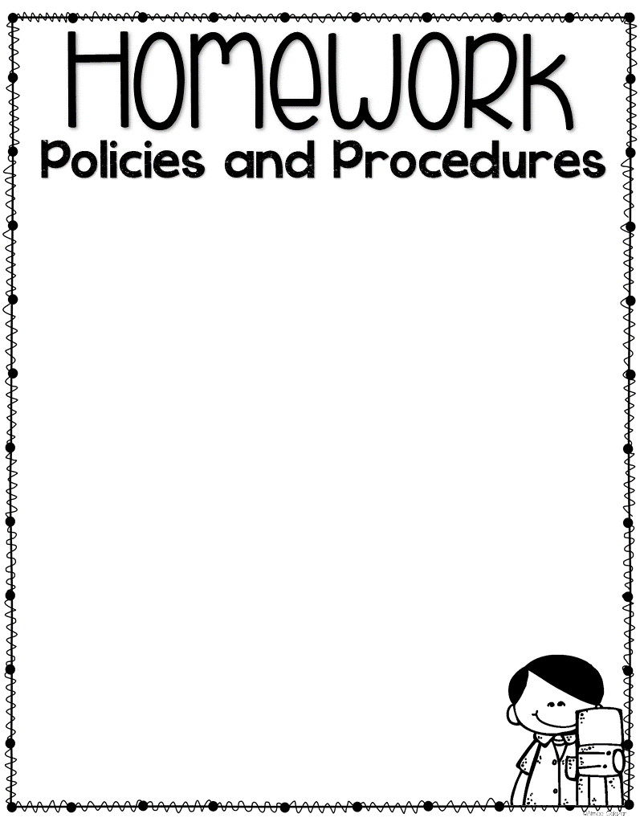

Each day your student works incredibly hard to become a better reader, writer, and mathematician. They explore, write, build, sing, create and socialize – it is a long day. When students arrive home, we do not want families burdened with hours of extra work. Extra-curricular activities and family time are important. Additionally, students need the opportunity to explore, play, and be little!
Research shows that developing fine and gross motor skills, building imaginative thinking skills, and fostering a sense of creativity are critically important skills for young learners. Also, these ‘non-academic’ skills build a strong foundation for the learning that happens inside our classroom. Therefore, this year we will be using an alternative to the traditional homework packet - an experience and play-based homework choice board.
Homework Folders: Starting September 12th, a two pocket folder will come home every Monday or the first day of the school week. Inside you will find a homework choice board for the month, a reading record star sheet, and a book. Turn this folder in every Friday so that we can give your child a new book to read for the week.
Monthly Choice Board: These choice boards are not meant to be daunting or overwhelming. Rather, they are intended to build fine and gross motor skills, creativity, and imaginative skills. As students complete an activity, they may color that square in, and they will return it at the end of the month to share with the teacher.
Reading Records: In addition to the attached choice board, we ask that you continue reading at home with your student each evening. Reading is a skill that will be lost if it is not practiced. Your child is required to read for at least 15 minutes every night. The book that will come home in their folder will match their reading level and should be read at least once each night. Your child may get tired of reading the same book over and over again. However, repeated reading supports their fluency, rate, and comprehension.
Then if students have other books at home or library books they would like
to read, they may do so. Another option is to read online via RazKids.
Happy Learning!

